Local Muslim leader speaks out on doctor accused of FGM
FOX2

By: Hannah Saunders
Posted: Apr 18 2017 06:39PM EDT
Updated: Apr 18 2017 07:33PM EDT

The sickening practice of female genital mutilation is still largely kept secret, so much so, that the FBI still doesn't know how many young girls in our own community are victims.
Although Henry Ford Dr. Jumana Nagarwala denies being guilty of the gruesome act, she says whatever she did to these young victims in an afterhours Livonia clinic, was a religious practice, based in the Dawoodi Bohra sect of Islam.
“I was shocked really at the allegations, we'll see how it plays out in court. The doctor alleges that she did no cutting.”
Dawud Walid of the Council on American Islamic relations says Nagarwala's claims of only taking mucus from girls around 7 years old, is not a known practice of any sect of Islam.
“I've never heard of any wiping away of mucus and burying it as an Islamic religious practice. I've never heard of this before.”
Nagarwala's sect of Islam is practiced at the Masjid-ul-Burhani mosque located on Orchard Lake Road in Farmington Hills.
We're told the people who attend the mosque mostly keep to themselves and don't normally communicate or participate in discussions or events with the larger Muslim community in SE Michigan.
“They have their own programs and are really more so to themselves.”
The FBI says they have strong evidence and testimony prepared to prove that at least two 7 year old girls were badly mutilated by Nagarwala in February.
We've tried to reach the Imam to ask if this sort of practice is condoned, but did not get a response.
FGM is however condemned by the Islamic faith as a whole.
“The council on American Islamic relations reaffirmed our long standing position on February 6 at the United Nations international Day against female genital mutilation that the cutting as well as removing of the female genitalia or FGM is un-Islamic and goes against our religious norm.”

Department of Justice
Office of Public Affairs

FOR IMMEDIATE RELEASE
Thursday, April 13, 2017

Detroit Emergency Room Doctor Arrested and Charged with Performing Female Genital Mutilation
A Detroit Emergency Room physician was charged by complaint for performing female genital mutilation (FGM) on minor females.
Acting Assistant Attorney General Kenneth A. Blanco of the Justice Department’s Criminal Division, Acting U.S. Attorney Daniel L. Lemisch of the Eastern District of Michigan, Special Agent in Charge David P. Gelios of the FBI’s Detroit Division and Special Agent in Charge Steve Francis of U.S. Immigration and Customs Enforcement’s Homeland Security Investigations (ICE-HSI) Detroit Field Office made the announcement.
Jumana Nagarwala, M.D., of Northville, Michigan, is charged with performing FGM on minor girls out of a medical office in Livonia, Michigan. According to the complaint, some of the minor victims allegedly traveled interstate to have Nagarwala perform the procedure. The complaint alleges that Nagarwala performed FGM on girls who were approximately six to eight years old. This is believed to be the first case brought under 18 U.S.C. 116, which criminalizes FGM. Nagarwala was arrested and is scheduled to appear in federal court in Detroit this afternoon.
“According to the complaint, despite her oath to care for her patients, Dr. Nagarwala is alleged to have performed horrifying acts of brutality on the most vulnerable victims,” said Acting Assistant Attorney General Blanco. “The Department of Justice is committed to stopping female genital mutilation in this country, and will use the full power of the law to ensure that no girls suffer such physical and emotional abuse.”
“Female genital mutilation constitutes a particularly brutal form of violence against women and girls. It is also a serious federal felony in the United States,” said Acting U.S. Attorney Lemisch. “The practice has no place in modern society and those who perform FGM on minors will be held accountable under federal law.”
“The allegations detailed in today’s criminal complaint are disturbing,” said Special Agent in Charge Gelios. “The FBI, along with its law enforcement partners, are committed to doing whatever necessary to bring an end to this barbaric practice and to ensure no additional children fall victim to this procedure.”
“The allegations against the defendant in this investigation are made even more deplorable, given the defendant’s position as a trusted medical professional in the community,” said Special Agent in Charge Francis. “My sincere hope is that these charges will give support to those who have allegedly suffered both physically and emotionally.”
A complaint is merely an allegation and the defendant is presumed innocent unless and until proven guilty beyond a reasonable doubt in a court of law.
The FBI’s Detroit Division and HSI investigated the case with support of the Criminal Division’s Fraud Section, the U.S. Attorney’s Office of the Eastern District of Michigan and the FBI’s International Human Rights Unit, Criminal Investigative Division. Deputy Chief Sara Woodward of the Eastern District of Michigan and Fraud Section Assistant Chief Nick Surmacz and Trial Attorneys Amy Markopoulos and Malisa Dubal are prosecuting the case.
The FBI’s Detroit Field Division has set up a tip line for anyone who has information pertaining to the illegal practice of FGM or Dr. Jumana Nagarwala. Please call 1-800-CALL-FBI (225-5324) or file an e-tip at FBI.GOV/FGM.
Nagarwala Complaint
Component(s):
Criminal Division
Criminal - Criminal Fraud Section
USAO - Michigan, Eastern
Press Release Number:
17-396

Feds Arrest Detroit Doctor for Female Genital Mutilation of Girls Across American Midwest
25093
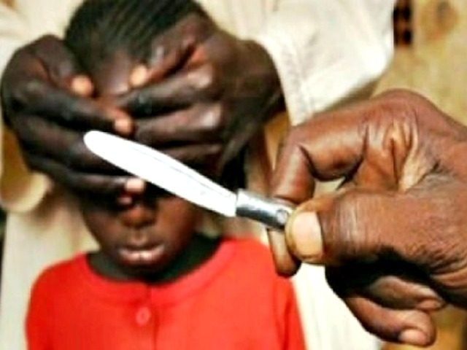
Reuters/James Akena
by Ian Mason13 Apr 2017Detroit, MI10,518

Dr. Jumana Nagarwala was arrested by the FBI Thursday and charged with carrying out female genital mutilation (FGM) on multiple six to eight-year-old girls at her Livonia, Michigan office.
Dr. Nagarwala’s case is the first FGM prosecution in America under a new law aimed at the practice, according to a press release from the Department of Justice. The 11-page complaint issued accompanying her arrest makes guarded references to “members of a particular religious and cultural community.”
FGM is common in the Islamic world, particularly in Africa. According to UNICEF, 98% of Somali girls, and 87% of Egyptians have endured the procedure. FGM involves removing varying amounts of the victim’s, usually a pre-pubescent girl, clitoris, labia majoria, and labia minora. In its most extreme form, the victim is “infibulated,” having virtually all her external genitalia removed and being sown up, leaving her with only a tiny hole from which to urinate and menstruate.
Nagarwala, who works as an emergency room doctor at Detroit’s Henry Ford Hospital, is charged with mutilating two Minnesota girls from separate families at her office in Livonia, Michigan. The victims’ identities remain sealed, but Minnesota is host to the largest Somali immigrant population in the United States, a community in which FGM is prevalent. The complaint also alleges multiple Michigan girls have told authorities Nagarwala had cut their genitals as far back as 2005-2007, before the federal law under which she is charged had taken effect.
advertisement
According to the complaint, the Minnesota victims’ parents brought them to the Detroit suburbs together, telling the children it was a “special girls trip.” They also are alleged to have told the girls the procedure was to “get the germs out.”
One of the victims described her ordeal to the FBI as “getting a shot.” She claims she screamed in pain as she was cut into, the procedure leaving her barely able to walk. She told authorities her parent told her not to talk of what happened in Dr. Nagarwala’s office.
DOJ officials issued statements about prosecuting this type of crime, heretofore unheard of in federal law enforcement. “The Department of Justice is committed to stopping female genital mutilation in this country, and will use the full power of the law to ensure that no girls suffer such physical and emotional abuse,” Acting Attorney General of the DOJ’s Criminal Division said as he announced the charges against Nagarwala.
Acting U.S. Attorney Daniel Lemisch, whose office will be prosecuting the case, added, “The practice has no place in modern society and those who perform FGM on minors will be held accountable under federal law.”
“The allegations against the defendant in this investigation are made even more deplorable, given the defendant’s position as a trusted medical professional in the community,” FBI Special Agent in Charge Francis.
Nagarwala faces a maximum of five years for each count of FGM.

Read More Stories About:
Big Government, Law Enforcement, FGM, Islam, Minnesota, S

Dr. Jumana Nagarwala to be released on $4.5 million bond while awaiting FGM trial

Supporters raise money for doctor's release in female genital mutilation case
By John Steckroth - Editor, Dave Bartkowiak Jr.
Posted: 12:02 PM, September 19, 2017 Updated: 5:31 PM, September 19, 2017
DETROIT - Dr. Jumana Nagarwala will be released from federal custody this week on a $4.5 million bond while she awaits trial on female genital mutilation charges.
Nagarwala, 44, of Northville, is charged with female genital mutilation and conspiracy.
Her bond was raised by supporters. She won't be released until later this week.
READ: Dr. Jumana Nagarwala fired by Henry Ford amid female genital mutilation case
She originally was denied bond because a judge considered her to be a flight risk. However, on Tuesday Nagarwala's attorneys offered this new $4.5 million bond proposal which was accepted by the judge.
If Nagarwala violates the terms of her bond or fails to appear for court, she and her husband would face the forfeiture of their Northville home and the 17 individuals who are guaranteeing her bond would be required to satisfy the remainder of the bond.
An attorney for Nagarwala admitted to her doing the procedures, but she insists that it is nothing more than a religious practice for Muslim families and that she has done nothing wrong.
The $4.5 million bond is believed to be the largest ever set in the U.S. District Court for Eastern Michigan.

Arrested in April
Nagarwala was arrested April 12 and detained April 17. Henry Ford Health System said she was placed on administrative leave April 13.
The hospital system released this statement:
"We were shocked by the allegations. The alleged criminal activity did not occur at any Henry Ford facility. We would never support or condone anything related to this practice. The doctor has immediately been placed on administrative leave."
On April 27, she was terminated from her position as an emergency department physician at Henry Ford Hospital in Detroit.

Several others charged in FGM case
Nagarwala is charged alongside Dr. Fakhruddin Attar and his wife, Farida Attar. Several other employees were charged in connection with the illegal procedures.
All six defendants were due in court for a pretrial hearing Tuesday.
The defense made multiple attempts to try to make it appear the Attars had nothing to do with the so-called "cuttings." The Attars claimed it was Nagarwala who did the medical procedures and performed the "closely held and time-honored religious practice."
Female genital mutilation: What is it, cultural and social factors
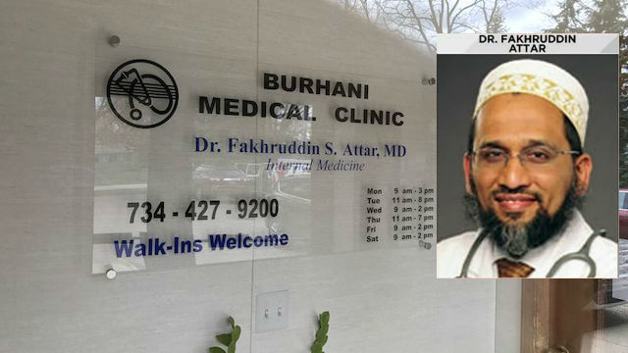
Dr. Fakhruddin Attar and the Burhani Medical Clinic in Livonia, Mich.

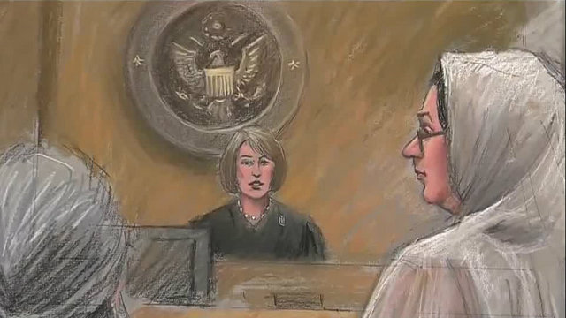
Dr. Jumana Nagarwala in court April 18, 2017. (Sketch by Jerry Lemenu)

Federal officials made their case by acknowledging they set up a full-scale surveillance on the doctors and the Burhani Medical Clinic in Livonia after receiving a tip about FGM. They even installed a live camera on a telephone pole outside the clinic.
Officials said for the past 12 years, Fakhruddin Attar allowed his clinics to host FGM procedures done by Nagarwala and assisted by his wife. They said they phoned and texted each other, telling each other to deny any FGM and plotting strategy.
MORE: FGM a serious problem in United States
Federal officials said one of the children picked Farida Attar and Nagarwala out of a picture lineup. One of the girls admitted she screamed in pain during the procedure and was told to be quiet about her so-called "girls' weekend."

Unprecedented charges
This case is unprecedented in the U.S. According to the United States code, "whoever knowingly circumcises, excises, or infibulates the whole or any part of the labia majora or labia minora or clitoris of another person who has not attained the age of 18 years shall be fined under this title or imprisoned not more than 5 years, or both."
Here are the Congressional Findings:
“(1) the practice of female genital mutilation is carried out by members of certain cultural and religious groups within the United States;
“(2) the practice of female genital mutilation often results in the occurrence of physical and psychological health effects that harm the women involved;
“(3) such mutilation infringes upon the guarantees of rights secured by Federal and State law, both statutory and constitutional;
“(4) the unique circumstances surrounding the practice of female genital mutilation place it beyond the ability of any single State or local jurisdiction to control;
“(5) the practice of female genital mutilation can be prohibited without abridging the exercise of any rights guaranteed under the first amendment to the Constitution or under any other law; and
“(6) Congress has the affirmative power under section 8 of article I, the necessary and proper clause, section 5 of the fourteenth Amendment, as well as under the treaty clause, to the Constitution to enact such legislation.”
MORE: Female genital mutilation a serious problem in United States

Investigation involves 2 girls from Minnesota
Court documents said Nagarwala's phone records revealed several phone calls to a family in Minnesota with a girl who just turned 7 years old. According to officials, the Minnesota family is part of the religious community in Minnesota that practices FGM.
Officials said the phone was tracked on Feb. 3 from Minnesota to Michigan. Someone used the phone that evening via a tower in Farmington Hills near multiple hotels, officials said. The phone was traced back to Minnesota on Feb. 4, officials said.
Investigators said surveillance video from Feb. 3 at a hotel in Farmington Hills showed two adult women and two young girls checking into two rooms. Officials believe that the two young girls were victims of FGM performed by Nagarwala.
"The allegations detailed in today’s criminal complaint are disturbing," FBI special agent in charge David Gelios said. "The FBI, along with its law enforcement partners, are committed to doing whatever is necessary to bring an end to this barbaric practice and to ensure no additional children fall victim to this procedure."
Investigators interviewed the two girls, who identified Nagarwala as the doctor who performed operations on them during a trip. They said their mother told them it was a "special" girls' trip, officials said. The girls told investigators that they were told by Nagarwala and their parents not to talk about the procedure.
One of the girls said she left a winter glove in the medical office. Officials executed a search warrant on Monday and found the glove in the medical clinic. Officials said the glove had the girl's first name written on it.
Investigators said doctors performed examinations on the young girls and found that FGM had been performed on them.

Other potential victims from Michigan
"The allegations against the defendant in this investigation are made even more deplorable, given the defendant’s position as a trusted medical professional in the community," HSI special agent in charge Steve Francis said. "My sincere hope is that these charges will give support to those who have allegedly suffered both physically and emotionally."
The investigation has identified other children who might have been victimized by Nagarwala between 2005 and 2007, including children in Michigan, officials said.
Child Protective Services personnel and FBI agents on Monday interviewed several young girls in Michigan who said procedures matching the description of FGM had been performed on them by Nagarwala.
Officials said some of the children's parents denied knowledge of the procedures, while others said they knew that Nagarwala had performed the procedures.
Sign up for ClickOnDetroit Email Newsletters (click here) for more stories like this.
Copyright 2017 by WDIV ClickOnDetroit - All rights reserved.

Nearly 100 Girls May Have Had Genitals Cut by Doctors in Michigan, Prosecutor Says
By Janice Williams On 6/8/17 at 2:12 PM
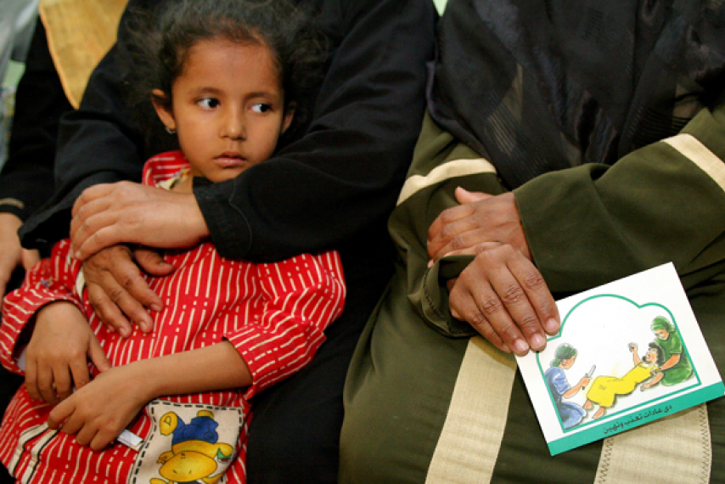People attend a session to educate women about the problems with female genital mutilation in Minia, Egypt, in 2006. A prosecutor working a female genital mutilation case in Michigan said on June 7 over 100 girls may have been cut there. Tara Todras-Whitehill/Reuters
Share
U.S. female genital mutilation Michigan
More than 200 million women and girls in over 30 countries have undergone female genital mutilation procedures, according to the World Health Organization, and some 3 million girls are estimated to be at risk of being subjected to the procedure, which can include partial or total removal of genitalia in an effort to suppress female sexuality.
While the procedure is more common in countries in Africa, the Middle East and Asia than in the U.S., a physician has recently been accused of cutting up to 100 girls in a doctor's office in Michigan.
Dr. Jumana Nagarwala, Dr. Fakhruddin Attar and his wife, Farida Attar, were arrested in April on three federal criminal counts, including aiding and abetting female genital mutilation, conspiracy and transportation of an individual with intent to engage in criminal sexual activity. It marks the first federal case regarding female genital mutilation in the U.S.
Keep up with this story and more by subscribing now
The trio was tied to a Muslim sect referred as Dawoodi Bohra that practices female genital mutilation, or FGM, for what it claims are religious and cultural reasons. They have been accused of allowing Nagarwala to use Attar’s Livonia-based Burhani Medical Clinic to perform the procedure on two 7-year-old girls from Minnesota.
During a trial hearing Wednesday, Assistant U.S. Attorney Sara Woodward told a federal judge at least 100 girls may have been cut at the clinic over a 12-year period, the Detroit Free Press reported.
“Due to the secretive nature of this procedure, we are unlikely to ever know how many children were cut by Dr. Nagarwala," Woodward said. "The Minnesota victims were not the first victims."
Woodward said there could potentially be more girls who have undergone FGM at the medical center following Attar’s admission that he allowed Nagarwala to use his office to perform surgeries on a number of girls at least six times a year. Attar has said he was unaware that Nagarwala was using the office to perform FGM.
Nagarwala, an emergency room physician who is primarily based in Detroit, and Attar are facing a possible life sentences. Attar’s wife, who has been accused of holding the girls’ hands and calming them during the painful procedure, is facing up to 20 years in prison.
Court documents said the Minnesota girls were told they were going to Michigan for a “special girls’ trip,” and their parents instructed them not to speak about the procedure. One of the girls told investigators that they were taken to the doctor’s office because their “tummies hurt” and the doctor was going to “get the germs out,” while the other told authorities following the procedure she could “barely walk, and that she felt pain all the way down to her ankles.”
The Attars were released on bond following the hearing under the condition that they surrender their passports and remain on house arrest with GPS tethers. Meanwhile, Nagarwala is set to remain in lockup pending the outcome of her trial, which is scheduled in October.

Female genital mutilation trial moved to June 2018
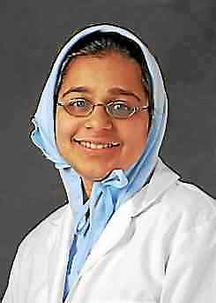Jumana Nagarwala
By Aileen Wingblad, awingblad@digitalfirstmedia.com,, @awingblad on Twitter
Posted: 10/05/17, 1:19 PM EDT | Updated: on 10/05/2017
1 Comment
The trial date for the landmark genital mutilation case involving a former Henry Ford Health System doctor and seven other defendants has again been moved forward – this time for eight months, to allow attorneys and prosecutors more opportunity to prepare.
ADVERTISING
The jury trial for Jumana Nagarwala and the others charged in connection with cutting the genitals of young girls at a Livonia clinic, which was set to begin Oct. 10 in Detroit’s federal court, is now scheduled for June 5, 2018. Earlier on, the trial was scheduled to begin this past June.
Nagarwala is charged alongside Dr. Fakhruddin Attar and his wife, Farida Attar for the illegal procedures which investigators say were performed at the Burhani Medical Clinic in Livonia, owned by Fakruddin Attar and managed by Farida Attar. It’s alleged Farida Attar held the hands of the young girls while the procedure was performed.
Five others are also charged in the case.
Advertisement
Prosecutors allege up to 100 girls might have had the procedure done by Nagarwala over the last 12 years.
READ MORE: 3 indicted in historic genital mutilation case
Couple accused of genital mutilation to be released from custody
4th charged in female genital mutilation case
2 more indicted in female genital mutilation case
Doctor in genital mutilation case to be released
U.S. District Judge Bernard Friedman ordered the trial postponement Sept. 29. In court records, Friedman states in part: “the ends of justice served by this delay outweighs the interests of the defendants and of the public in a speedy trial.”
Further, Friedman describes the case as “so unusual and complex due to the number of defendants, the nature of the prosecution, and the large volume of discovery, such that it would be unreasonable to expect adequate preparation for pretrial proceedings including motions, within the limits established by the Speedy Trial Act.”
All eight defendants are ordered to appear for a status conference before Friedman on Nov. 21.

